Spring Core - Maven

# Exercise 01

BookRepository.java

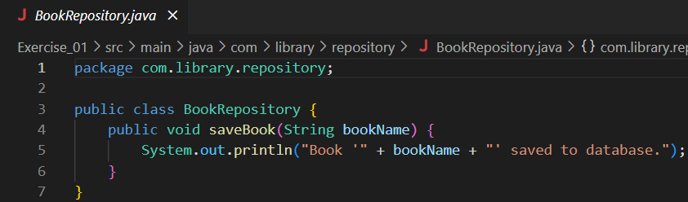

BookService.java

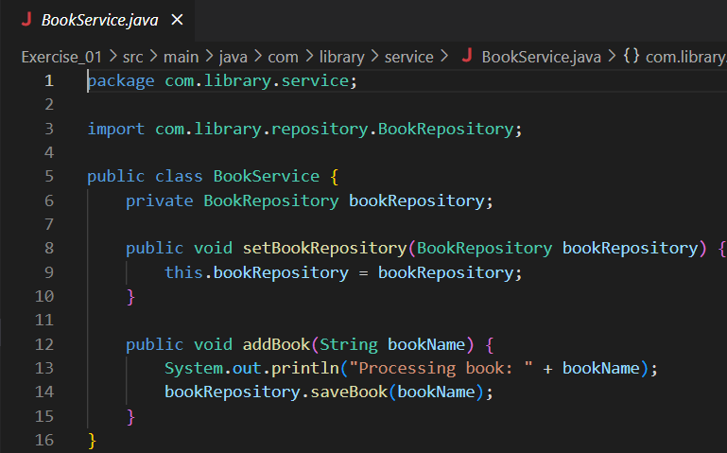

MainApp.java

applicationContext.xml

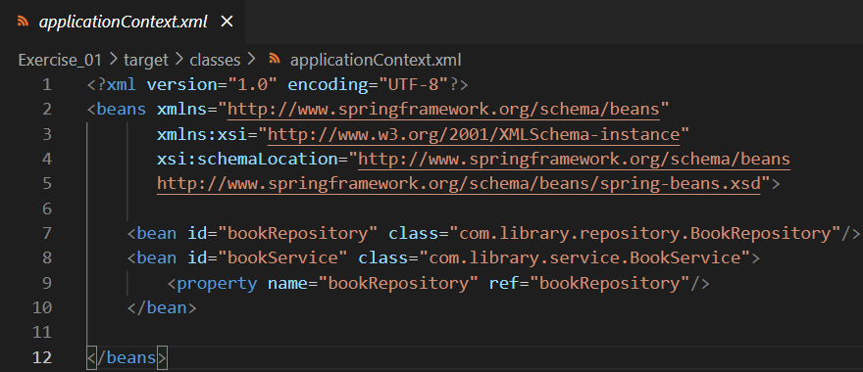

Pom.xml

Output:

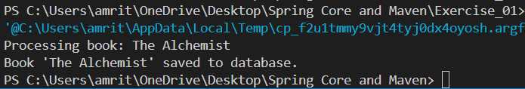

# Exercise 02

BookRepository.java

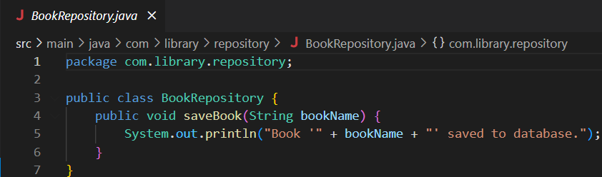

MainApp.java

applicationContext.xml

Pom.xml

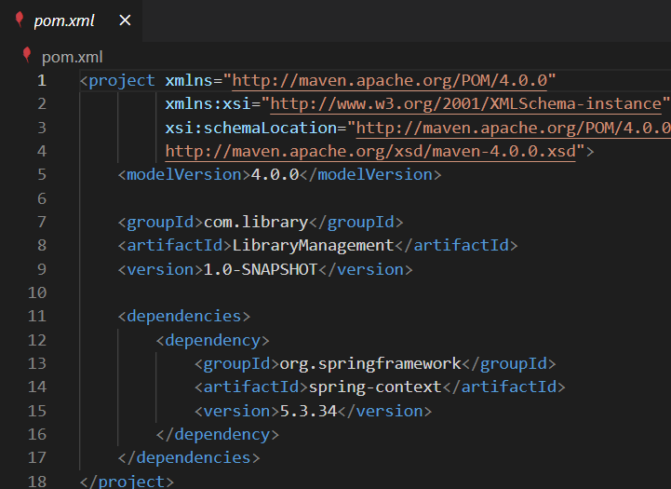

Output:

# Exercise 04

App.java

Pom.xml

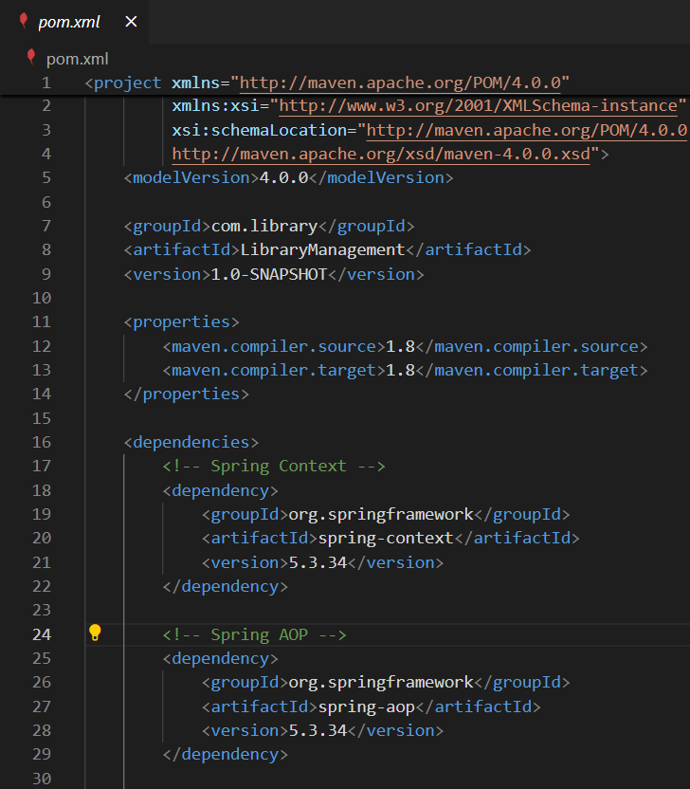

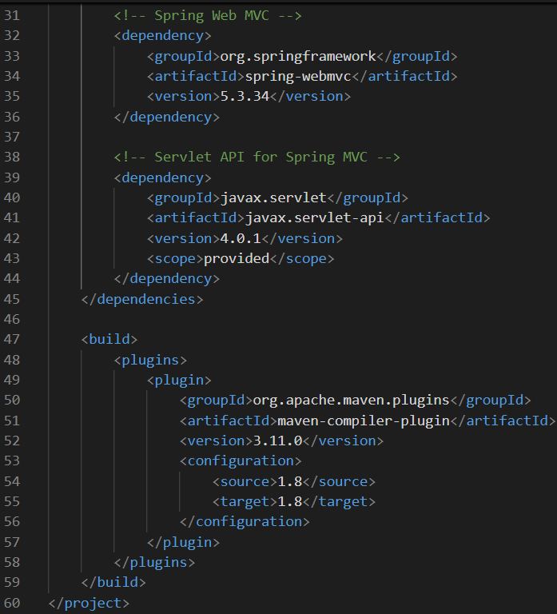

Output:

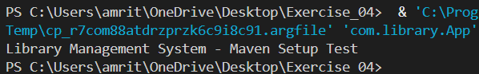

# Exercise 05

BookRepositor.java

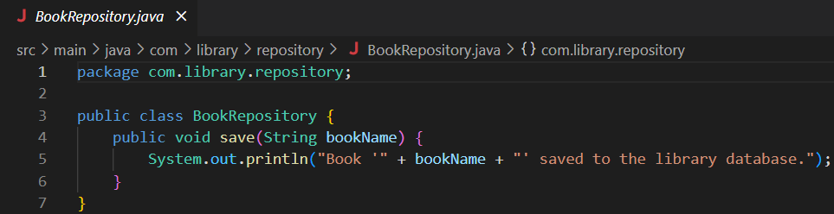

BookService.java

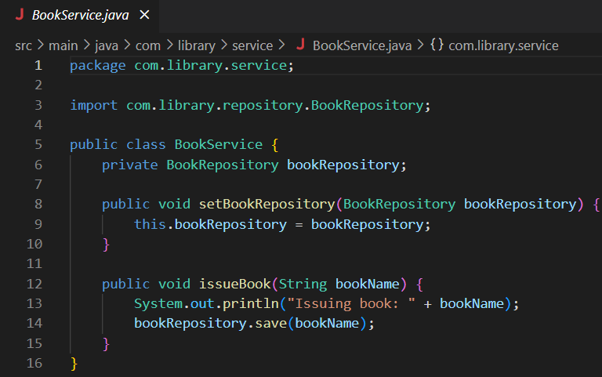

MainApp.java

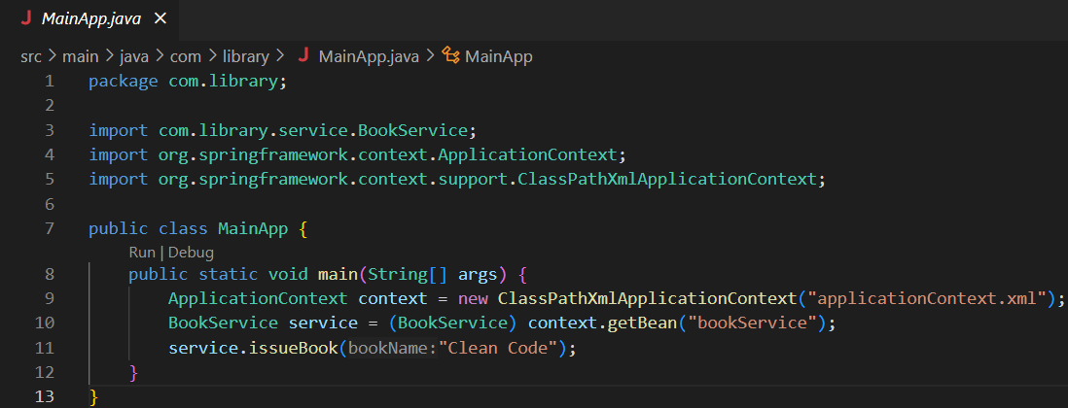

applicationContext.xml

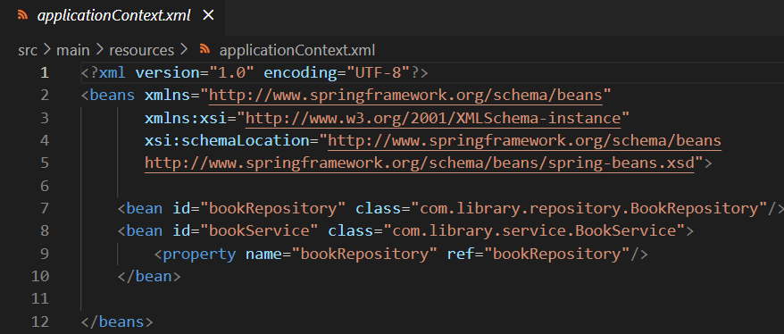

pom.xml

Output:

# Exercise 07

BookRepository.java

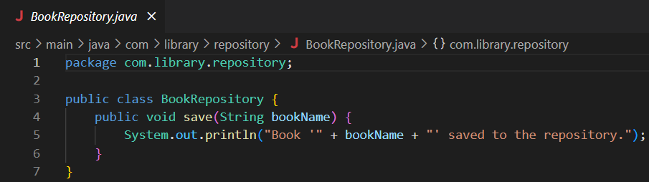

BookService.java

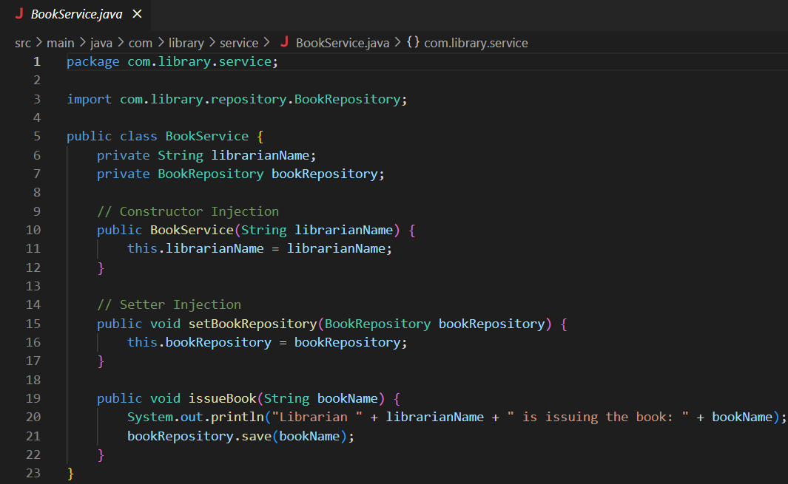

MainApp.java

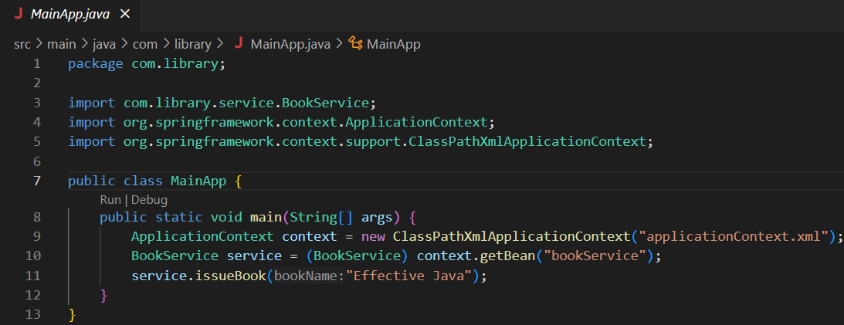

applicationContext.xml

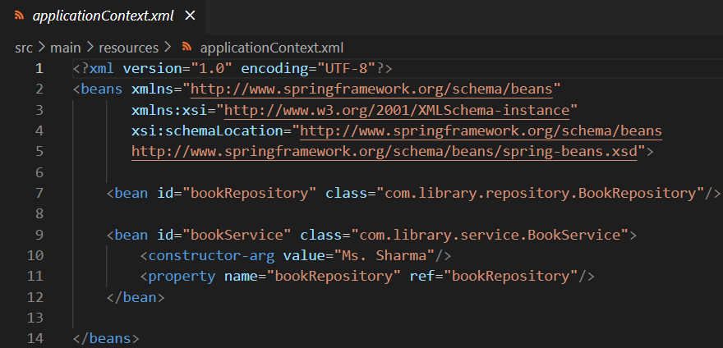

Pom.xml

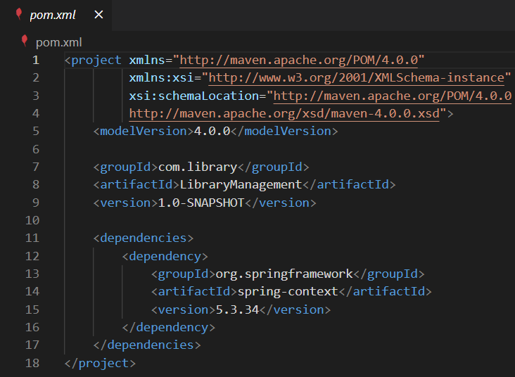

Output:

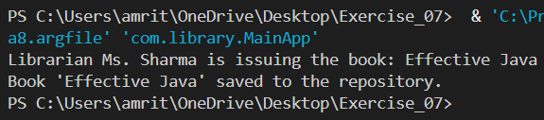

# Exercise 09

Book.java

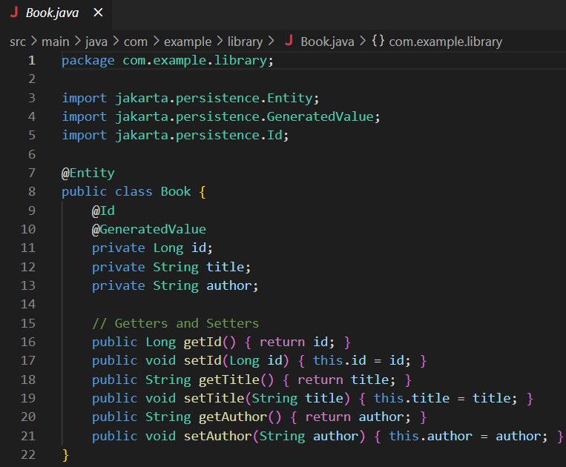

BookController.java

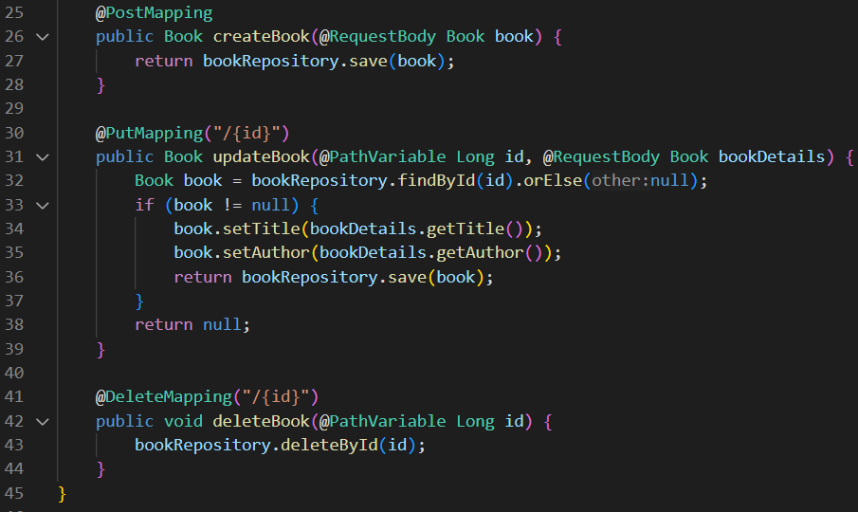

BookRepository.java

LibraryManagementApplication.java

pom.xml

Output:

